Diseño e Implementación de Chips y Circuitos Lógicos

Isabella Cadavid Posada

Clase: Organización de Computadores
Jose Luis Montoya Pareja

Escuela de Ingenierías y Ciencias Aplicadas, Universidad EAFIT

2026
TABLA DE CONTENIDO

INTRODUCCIÓN 3
1. NOT 4
2. AND 5
3. OR 6
4. XOR 8
5. MUX 9
6. DMUX 11
7. Not16 12
8. And16 13
9. Or16 14
10. Mux16 15
11. Or8Way 16
12. Mux4Way16 17
13. Mux8Way16 18
14. DMux4Way 19
15. DMux8Way 20
16. Full Adder: 21
17. HalfAdder 23
18. FullAdder Resumido: 24
19. Add16 25
20. Inc16 26

INTRODUCCIÓN
En el presente documento se describe el diseño e implementación de diferentes chips y circuitos lógicos desarrollados en el entorno Nand2Tetris, así como su respectiva construcción y simulación en Logisim. Se presentan los chips junto con sus circuitos correspondientes, abarcando compuertas básicas, multiplexores, demultiplexores y estructuras aritméticas de 16 bits, fundamentales en la arquitectura de computadores.
El desarrollo de estos componentes permite comprender cómo, a partir de compuertas elementales como NOT, AND y OR, es posible construir estructuras más complejas como multiplexores, sumadores completos y circuitos aritméticos de mayor capacidad. Cada chip fue implementado utilizando únicamente componentes previamente construidos, siguiendo el principio de diseño jerárquico y modular.

- NOT
CHIP Not {
IN in;
OUT out;

PARTS:
Nand(a= in, b=in , out=out );
}

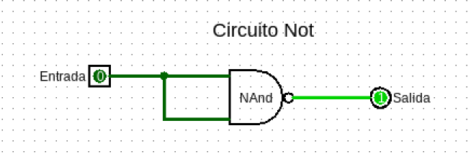

- AND
CHIP And {
IN a, b;
OUT out;

PARTS:
Nand(a=a , b=b , out=And1 );
Not(in=And1, out=out );
}

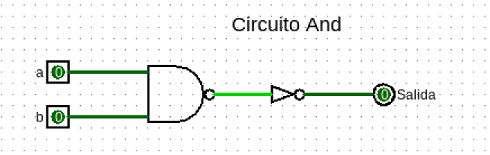

- OR
1 Forma
CHIP Or {
IN a, b;
OUT out;

PARTS:
Not(in=a , out=notA );
Not(in=b , out=notB );
Nand(a= notA, b=notB , out= out);
}

2 Forma
CHIP Or {
IN a, b;
OUT out;

PARTS:
Not(in=a , out=notA );
Not(in=b , out=notB );
And(a= notA, b=notB , out= And1);
Not(in=And1 , out=out );
}

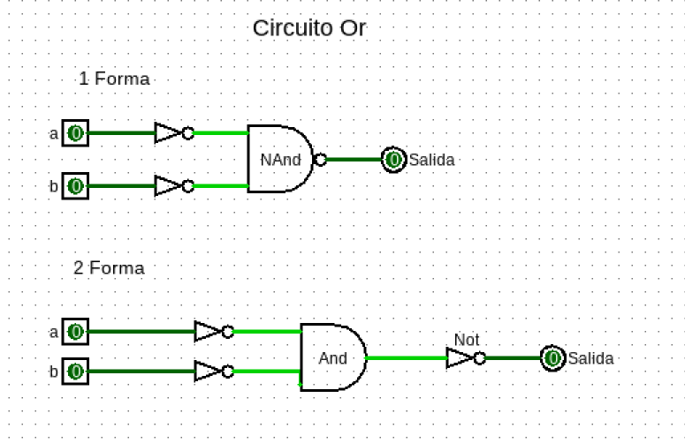

- XOR
CHIP Xor {
IN a, b;
OUT out;

PARTS:
Not(in=a , out=notA );
Not(in=b , out=notB );

And(a=notA , b=b , out=And1 );
And(a=a , b=notB , out=And2 );

Or(a=And1 , b=And2 , out=out );
}

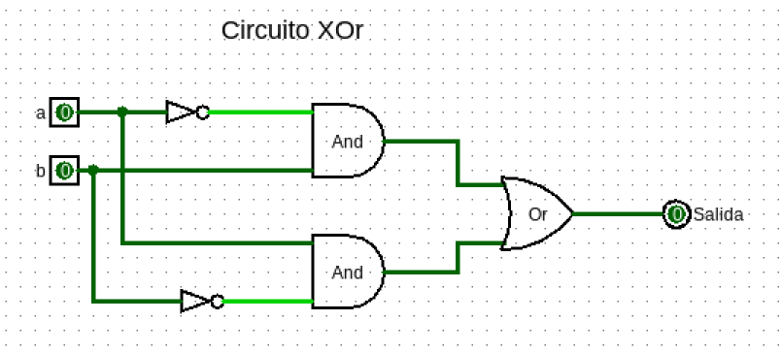

- MUX
1 Forma
CHIP Mux {
IN a, b, sel;
OUT out;

PARTS:
Not(in=sel, out=notSel);

Not(in=a, out=notA);
Not(in=b, out=notB);

And(a=notSel, b=a, out=and1A);
And(a=and1A, b=notB, out=and1);

And(a=notSel, b=a, out=and2A);
And(a=and2A, b=b, out=and2);

And(a=sel, b=notA, out=and3A);
And(a=and3A, b=b, out=and3);

And(a=sel, b=a, out=and4A);
And(a=and4A, b=b, out=and4);

Or(a=and1, b=and2, out=or1);
Or(a=and3, b=and4, out=or2);
Or(a=or1, b=or2, out=out);
}

2 Forma
CHIP Mux {
IN a, b, sel;
OUT out;

PARTS:
Not(in=sel , out=notSel );
And(a=notSel , b=a , out=and1 );
And(a=sel , b=b , out=and2 );
Or(a=and1 , b=and2 , out=out );
}

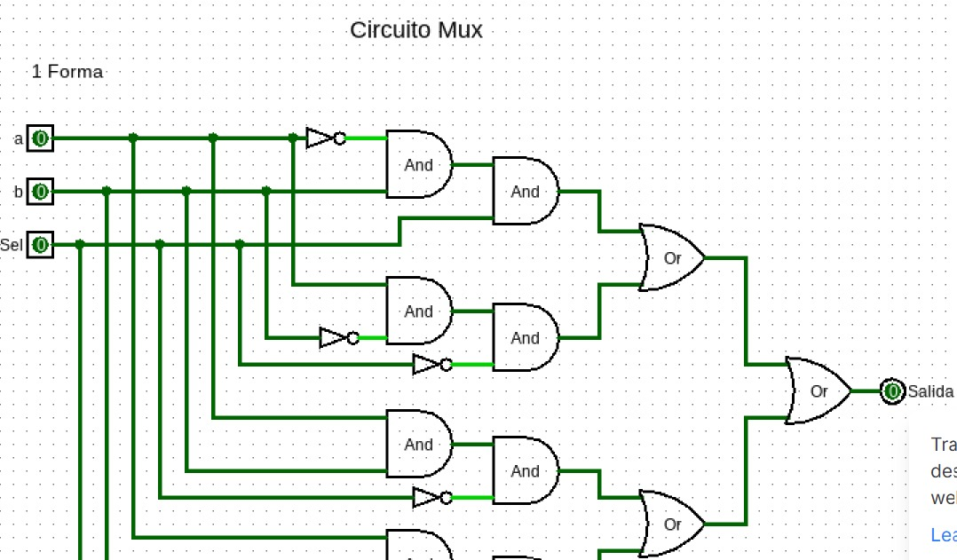
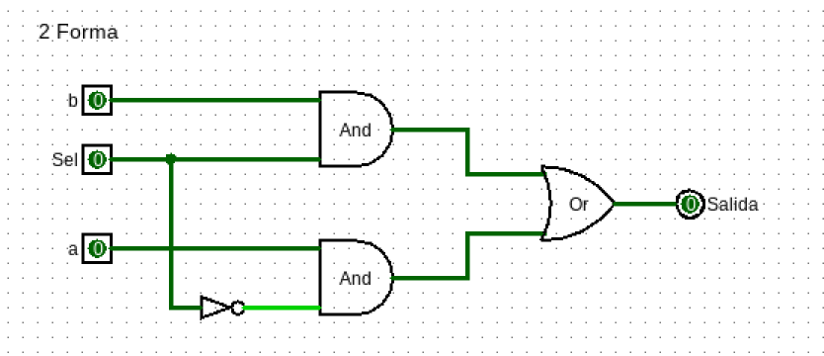

- DMUX

CHIP DMux {
IN in, sel;
OUT a, b;

PARTS:
Not(in=sel, out=notS);
And(a=in, b=notS, out=a);
And(a=in, b=sel, out=b);
}

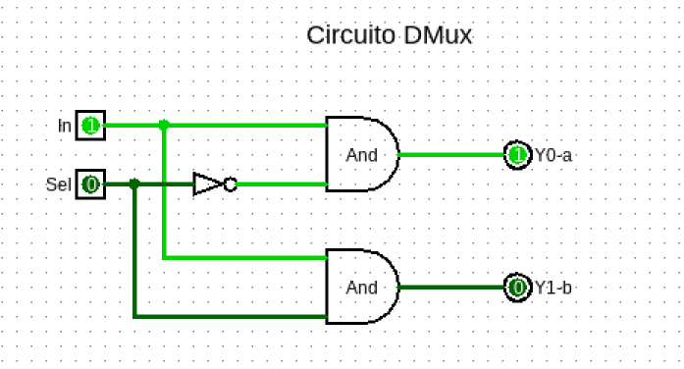

- Not16
CHIP Not16 {
IN in[16];
OUT out[16];

PARTS:
Not(in=in[0] , out=out[0]);
Not(in=in[1] , out=out[1]);
Not(in=in[2] , out=out[2]);
Not(in=in[3] , out=out[3]);
Not(in=in[4] , out=out[4]);
Not(in=in[5] , out=out[5]);
Not(in=in[6] , out=out[6]);
Not(in=in[7] , out=out[7]);
Not(in=in[8] , out=out[8]);
Not(in=in[9] , out=out[9]);
Not(in=in[10] , out=out[10]);
Not(in=in[11] , out=out[11]);
Not(in=in[12] , out=out[12]);
Not(in=in[13] , out=out[13]);
Not(in=in[14] , out=out[14]);
Not(in=in[15] , out=out[15]);

}

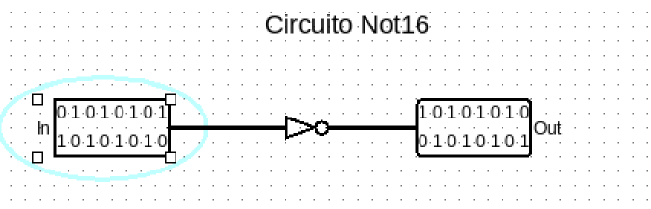
- And16
CHIP And16 {
IN a[16], b[16];
OUT out[16];

PARTS:
And(a=a[0], b=b[0], out=out[0]);
And(a=a[1], b=b[1], out=out[1]);
And(a=a[2], b=b[2], out=out[2]);
And(a=a[3], b=b[3], out=out[3]);
And(a=a[4], b=b[4], out=out[4]);
And(a=a[5], b=b[5], out=out[5]);
And(a=a[6], b=b[6], out=out[6]);
And(a=a[7], b=b[7], out=out[7]);
And(a=a[8], b=b[8], out=out[8]);
And(a=a[9], b=b[9], out=out[9]);
And(a=a[10], b=b[10], out=out[10]);
And(a=a[11], b=b[11], out=out[11]);
And(a=a[12], b=b[12], out=out[12]);
And(a=a[13], b=b[13], out=out[13]);
And(a=a[14], b=b[14], out=out[14]);
And(a=a[15], b=b[15], out=out[15]);
}

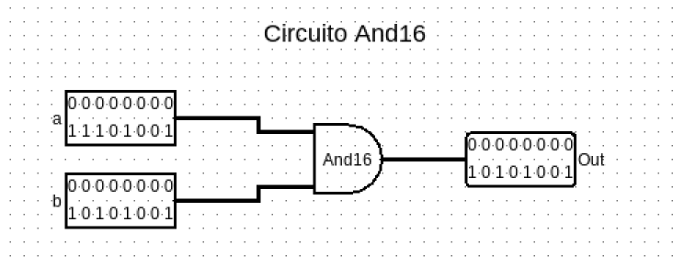
- Or16
CHIP Or16 {
IN a[16], b[16];
OUT out[16];

PARTS:
Or(a=a[0], b=b[0], out=out[0]);
Or(a=a[1], b=b[1], out=out[1]);
Or(a=a[2], b=b[2], out=out[2]);
Or(a=a[3], b=b[3], out=out[3]);
Or(a=a[4], b=b[4], out=out[4]);
Or(a=a[5], b=b[5], out=out[5]);
Or(a=a[6], b=b[6], out=out[6]);
Or(a=a[7], b=b[7], out=out[7]);
Or(a=a[8], b=b[8], out=out[8]);
Or(a=a[9], b=b[9], out=out[9]);
Or(a=a[10], b=b[10], out=out[10]);
Or(a=a[11], b=b[11], out=out[11]);
Or(a=a[12], b=b[12], out=out[12]);
Or(a=a[13], b=b[13], out=out[13]);
Or(a=a[14], b=b[14], out=out[14]);
Or(a=a[15], b=b[15], out=out[15]);
}

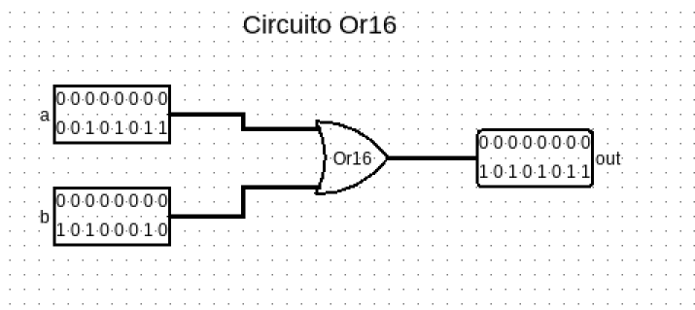
- Mux16
CHIP Mux16 {
IN a[16], b[16], sel;
OUT out[16];

PARTS:
Mux(a=a[0], b=b[0], sel=sel, out=out[0]);
Mux(a=a[1], b=b[1], sel=sel, out=out[1]);
Mux(a=a[2], b=b[2], sel=sel, out=out[2]);
Mux(a=a[3], b=b[3], sel=sel, out=out[3]);
Mux(a=a[4], b=b[4], sel=sel, out=out[4]);
Mux(a=a[5], b=b[5], sel=sel, out=out[5]);
Mux(a=a[6], b=b[6], sel=sel, out=out[6]);
Mux(a=a[7], b=b[7], sel=sel, out=out[7]);
Mux(a=a[8], b=b[8], sel=sel, out=out[8]);
Mux(a=a[9], b=b[9], sel=sel, out=out[9]);
Mux(a=a[10], b=b[10], sel=sel, out=out[10]);
Mux(a=a[11], b=b[11], sel=sel, out=out[11]);
Mux(a=a[12], b=b[12], sel=sel, out=out[12]);
Mux(a=a[13], b=b[13], sel=sel, out=out[13]);
Mux(a=a[14], b=b[14], sel=sel, out=out[14]);
Mux(a=a[15], b=b[15], sel=sel, out=out[15]);
}

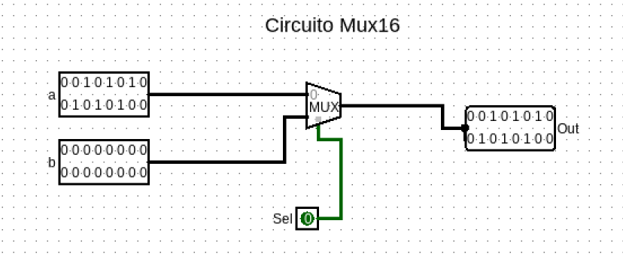
- Or8Way
CHIP Or8Way {
IN in[8];
OUT out;

PARTS:
Or(a=in[0], b=in[1], out=or1);
Or(a=in[2], b=in[3], out=or2);
Or(a=in[4], b=in[5], out=or3);
Or(a=in[6], b=in[7], out=or4);

Or(a=or1, b=or2, out=or5);
Or(a=or3, b=or4, out=or6);

Or(a=or5, b=or6, out=out);
}

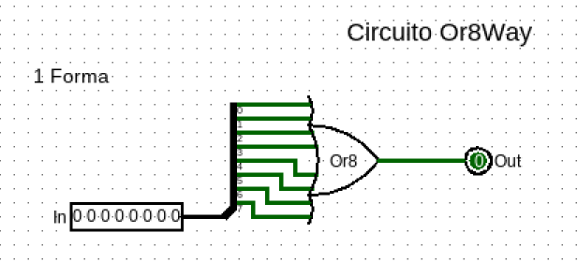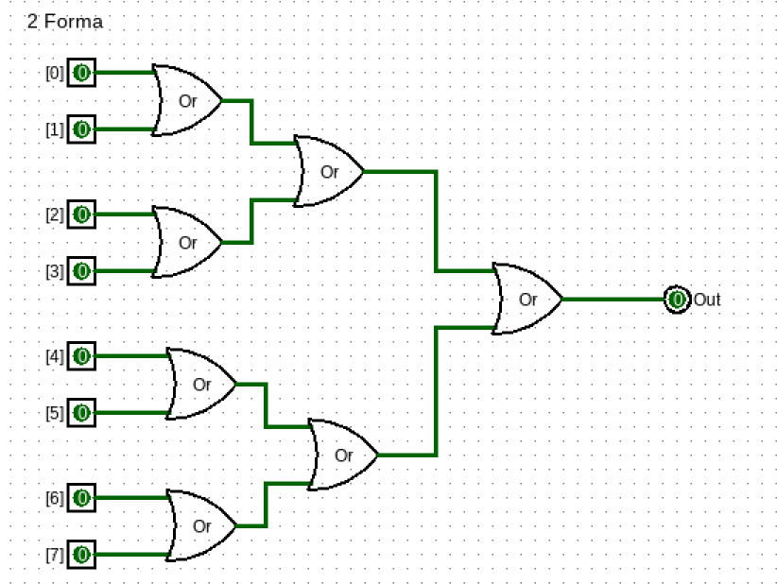

- Mux4Way16

CHIP Mux4Way16 {
IN a[16], b[16], c[16], d[16], sel[2];
OUT out[16];

PARTS:
Mux16(a=a, b=b, sel=sel[0], out=eleccionAB);
Mux16(a=c, b=d, sel=sel[0], out=eleccionCD);

Mux16(a=eleccionAB, b=eleccionCD, sel=sel[1], out=out);
}

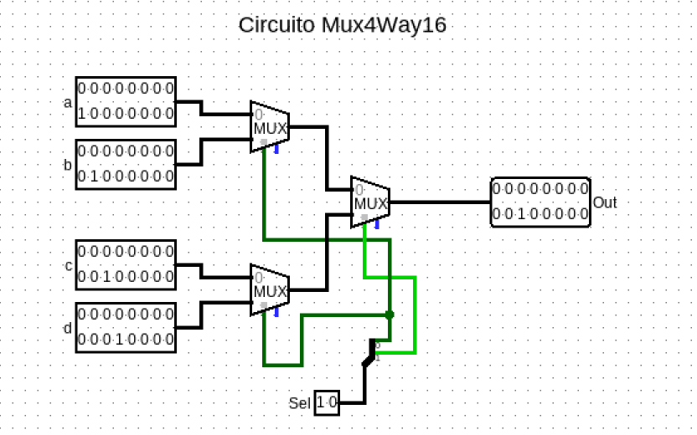

- Mux8Way16

CHIP Mux8Way16 {
IN a[16], b[16], c[16], d[16],
e[16], f[16], g[16], h[16],
sel[3];
OUT out[16];

PARTS:
Mux4Way16(a=a, b=b, c=c, d=d, sel=sel[0..1], out=out1);
Mux4Way16(a=e, b=f, c=g, d=h, sel=sel[0..1], out=out2);
Mux16(a=out1, b=out2, sel=sel[2], out=out);
}

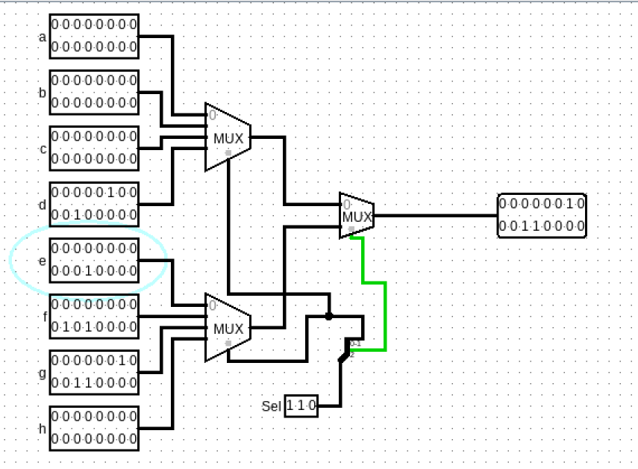

- DMux4Way
CHIP DMux4Way {
IN in, sel[2];
OUT a, b, c, d;

PARTS:
DMux(in=in, sel=sel[1], a=ab, b=cd);
DMux(in=ab, sel=sel[0], a=a, b=b);
DMux(in=cd, sel=sel[0], a=c, b=d);
}

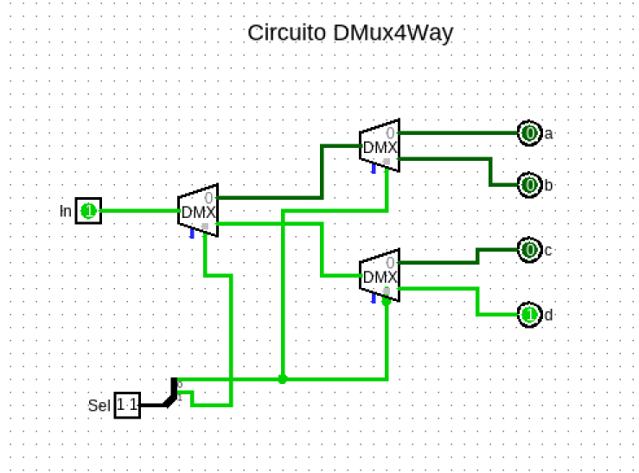

- DMux8Way
CHIP DMux8Way {
IN in, sel[3];
OUT a, b, c, d, e, f, g, h;

PARTS:
DMux(in=in , sel=sel[2] , a=abcd , b=efgh );

DMux(in=abcd, sel=sel[1], a=ab, b=cd);
DMux(in=efgh, sel=sel[1], a=ef, b=gh);

DMux(in=ab, sel=sel[0], a=a, b=b);
DMux(in=cd, sel=sel[0], a=c, b=d);
DMux(in=ef, sel=sel[0], a=e, b=f);
DMux(in=gh, sel=sel[0], a=g, b=h);

}

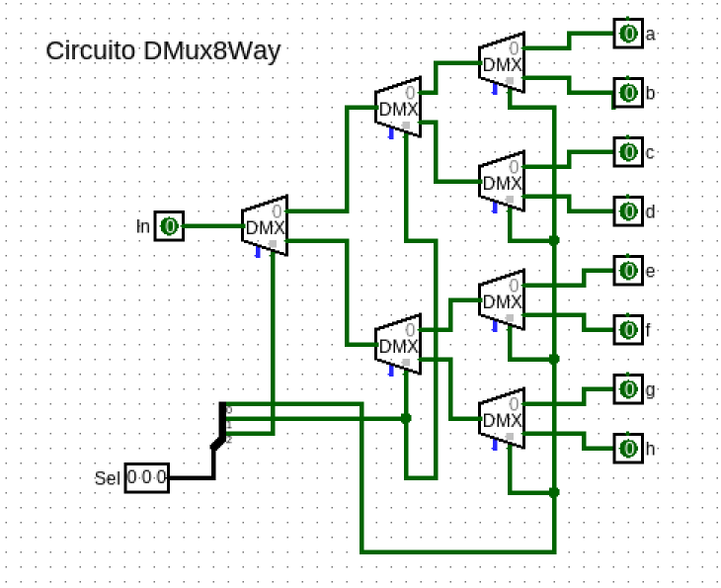
- Full Adder:

CHIP FullAdder {
IN a, b, c; // 1-bit inputs
OUT sum, // Right bit of a + b + c
carry; // Left bit of a + b + c

PARTS:
Not(in=a , out=notA );
Not(in=b , out=notB );
Not(in=c , out=notC );

And(a=notA , b=notB , out=and1);
And(a=and1 , b=c , out=out1);

And(a=notA , b=b , out=and2);
And(a=and2 , b=notC , out=out2);

And(a=a , b=notB , out=and3);
And(a=and3 , b=notC , out=out3);

And(a=a , b=b , out=and4);
And(a=and4 , b=c , out=out4);

Or(a=out1, b=out2, out=salida1 );
Or(a=out3 , b=out4 , out=salida2 );
Or(a=salida1 , b=salida2 , out=sum );

//Carry
And(a=notA , b=b , out=andCarry1 );
And(a=andCarry1 , b=c , out=outcarry1 );

And(a=a , b=notB , out=andCarry2 );
And(a=andCarry2 , b=c , out=outcarry2 );

And(a=a , b=b , out=andCarry3 );
And(a=andCarry3 , b=notC , out=outcarry3 );

And(a=a , b=b , out=andCarry4 );
And(a=andCarry4 , b=c , out=outcarry4 );

Or(a=outcarry1 , b=outcarry2 , out=salidacarry1);
Or(a=outcarry3 , b=outcarry4 , out=salidacarry2);
Or(a=salidacarry1 , b=salidacarry2 , out=carry);

}

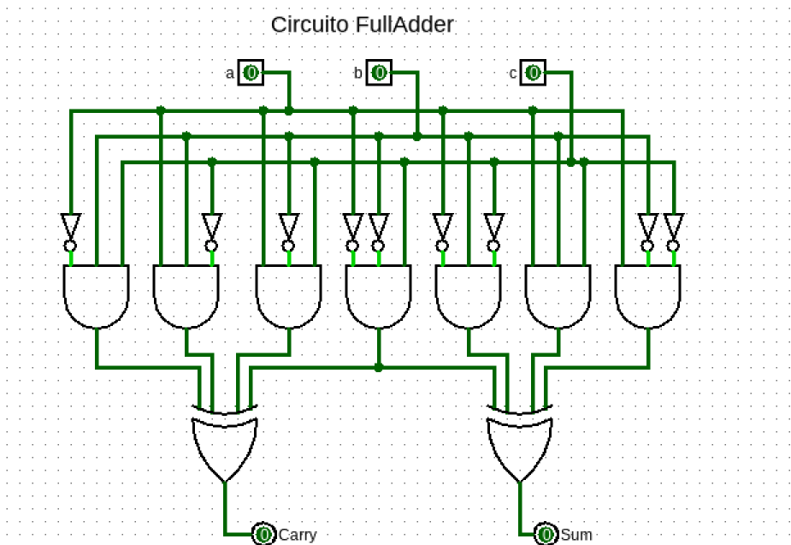

- HalfAdder
CHIP HalfAdder {
IN a, b;
OUT sum, carry;

PARTS:
Xor(a=a, b=b, out=sum);
And(a=a, b=b, out=carry);
}

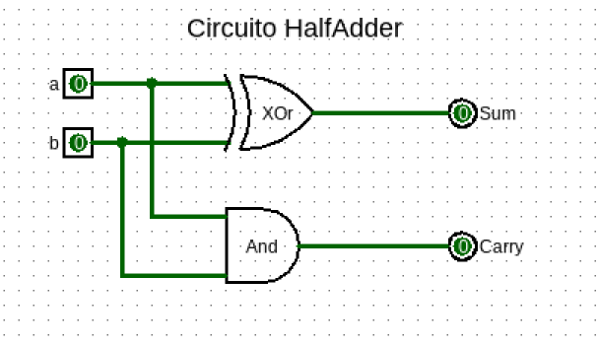

- FullAdder Resumido:
CHIP FullAdder {
IN a, b, c;
OUT sum,
carry;

PARTS:
Xor(a=a, b=b, out=x);

Xor(a=x, b=c, out=sum);

And(a=a, b=b, out=ab);
And(a=x, b=c, out=xc);
Or(a=ab, b=xc, out=carry);

}

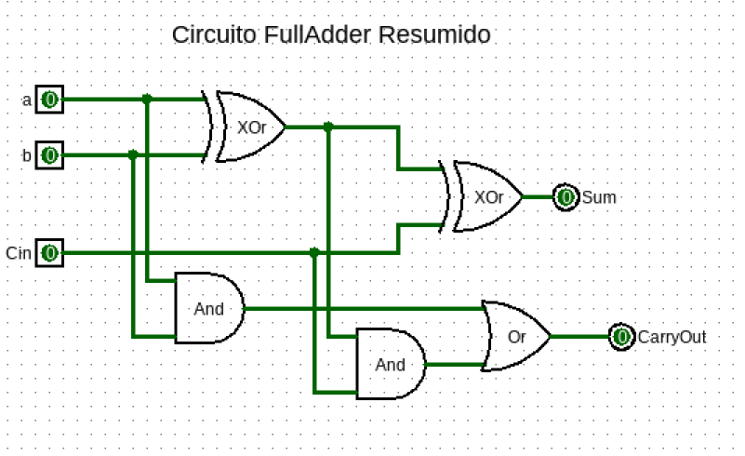

- Add16
CHIP Add16 {
IN a[16], b[16];
OUT out[16];

PARTS:
HalfAdder(a=a[0], b=b[0], sum=out[0], carry=c1);

// bits 1 a 15
FullAdder(a=a[1], b=b[1], c=c1, sum=out[1], carry=c2);
FullAdder(a=a[2], b=b[2], c=c2, sum=out[2], carry=c3);
FullAdder(a=a[3], b=b[3], c=c3, sum=out[3], carry=c4);
FullAdder(a=a[4], b=b[4], c=c4, sum=out[4], carry=c5);
FullAdder(a=a[5], b=b[5], c=c5, sum=out[5], carry=c6);
FullAdder(a=a[6], b=b[6], c=c6, sum=out[6], carry=c7);
FullAdder(a=a[7], b=b[7], c=c7, sum=out[7], carry=c8);
FullAdder(a=a[8], b=b[8], c=c8, sum=out[8], carry=c9);
FullAdder(a=a[9], b=b[9], c=c9, sum=out[9], carry=c10);
FullAdder(a=a[10], b=b[10], c=c10, sum=out[10], carry=c11);
FullAdder(a=a[11], b=b[11], c=c11, sum=out[11], carry=c12);
FullAdder(a=a[12], b=b[12], c=c12, sum=out[12], carry=c13);
FullAdder(a=a[13], b=b[13], c=c13, sum=out[13], carry=c14);
FullAdder(a=a[14], b=b[14], c=c14, sum=out[14], carry=c15);
FullAdder(a=a[15], b=b[15], c=c15, sum=out[15], carry=ignore);
}

- Inc16

1 Forma
CHIP Inc16 {
IN in[16];
OUT out[16];

PARTS:
// El primer bit suma el bit de entrada con 'true' (1)
HalfAdder(a=in[0], b=true, sum=out[0], carry=c0);

// Los siguientes bits suman su entrada con el acarreo anterior
HalfAdder(a=in[1], b=c0, sum=out[1], carry=c1);
HalfAdder(a=in[2], b=c1, sum=out[2], carry=c2);
HalfAdder(a=in[3], b=c2, sum=out[3], carry=c3);
HalfAdder(a=in[4], b=c3, sum=out[4], carry=c4);
HalfAdder(a=in[5], b=c4, sum=out[5], carry=c5);
HalfAdder(a=in[6], b=c5, sum=out[6], carry=c6);
HalfAdder(a=in[7], b=c6, sum=out[7], carry=c7);
HalfAdder(a=in[8], b=c7, sum=out[8], carry=c8);
HalfAdder(a=in[9], b=c8, sum=out[9], carry=c9);
HalfAdder(a=in[10], b=c9, sum=out[10], carry=c10);
HalfAdder(a=in[11], b=c10, sum=out[11], carry=c11);
HalfAdder(a=in[12], b=c11, sum=out[12], carry=c12);
HalfAdder(a=in[13], b=c12, sum=out[13], carry=c13);
HalfAdder(a=in[14], b=c13, sum=out[14], carry=c14);
HalfAdder(a=in[15], b=c14, sum=out[15], carry=ignore);
// El último acarreo (c15) se ignora en un incrementador estándar de 16 bits

}

2 Forma
CHIP Inc16 {
IN in[16];
OUT out[16];

PARTS:
// El incremento es sumar 1. Usamos un sumador de 16 bits.
Add16(a=in, b[0]=true, b[1..15]=false, out=out);
}

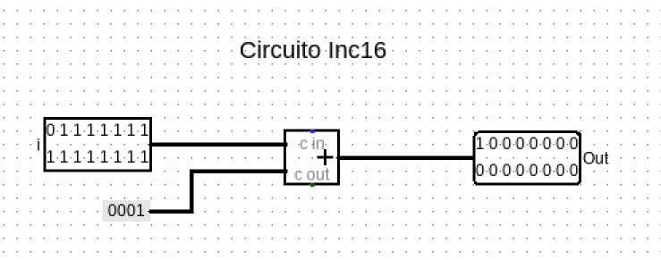

- Bit

CHIP Bit {
IN in, load;
OUT out;

PARTS:
Mux(a=outMux , b=in , sel= load , out=DFF1 );

DFF(in=DFF1 , out=out, out=outMux );
}

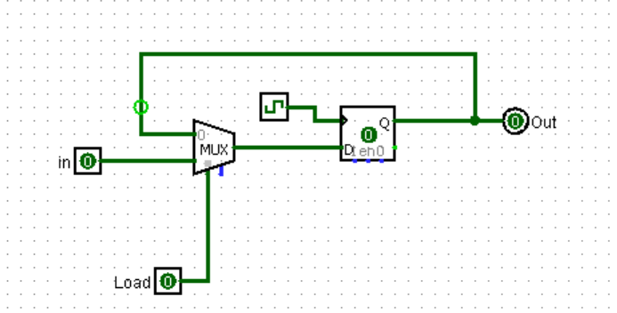

- Registre
CHIP Register {
IN in[16], load;
OUT out[16];
PARTS:
Bit(in=in[0] , load=load , out=out[0] );
Bit(in=in[1] , load=load , out=out[1] );
Bit(in=in[2] , load=load , out=out[2] );
Bit(in=in[3] , load=load , out=out[3] );
Bit(in=in[4] , load=load , out=out[4] );
Bit(in=in[5] , load=load , out=out[5] );
Bit(in=in[6] , load=load , out=out[6] );
Bit(in=in[7] , load=load , out=out[7] );
Bit(in=in[8] , load=load , out=out[8] );
Bit(in=in[9] , load=load , out=out[9] );
Bit(in=in[10] , load=load , out=out[10] );
Bit(in=in[11] , load=load , out=out[11] );
Bit(in=in[12] , load=load , out=out[12] );
Bit(in=in[13] , load=load , out=out[13] );
Bit(in=in[14] , load=load , out=out[14] );
Bit(in=in[15] , load=load , out=out[15] );
}
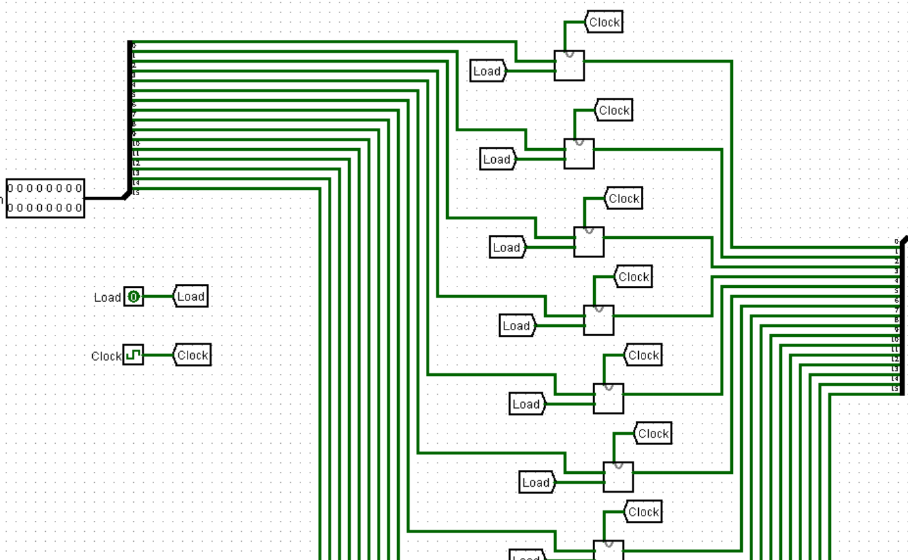
- RAM8
CHIP RAM8 {
IN in[16], load, address[3];
OUT out[16];
PARTS:
DMux8Way(in=load, sel=address, a=load0, b=load1, c=load2, d=load3, e=load4, f=load5, g=load6, h=load7);
Register(in=in, load=load0, out=reg0);
Register(in=in, load=load1, out=reg1);
Register(in=in, load=load2, out=reg2);
Register(in=in, load=load3, out=reg3);
Register(in=in, load=load4, out=reg4);
Register(in=in, load=load5, out=reg5);
Register(in=in, load=load6, out=reg6);
Register(in=in, load=load7, out=reg7);
Mux8Way16(a=reg0, b=reg1, c=reg2, d=reg3, e=reg4, f=reg5, g=reg6, h=reg7, sel=address, out=out);
}
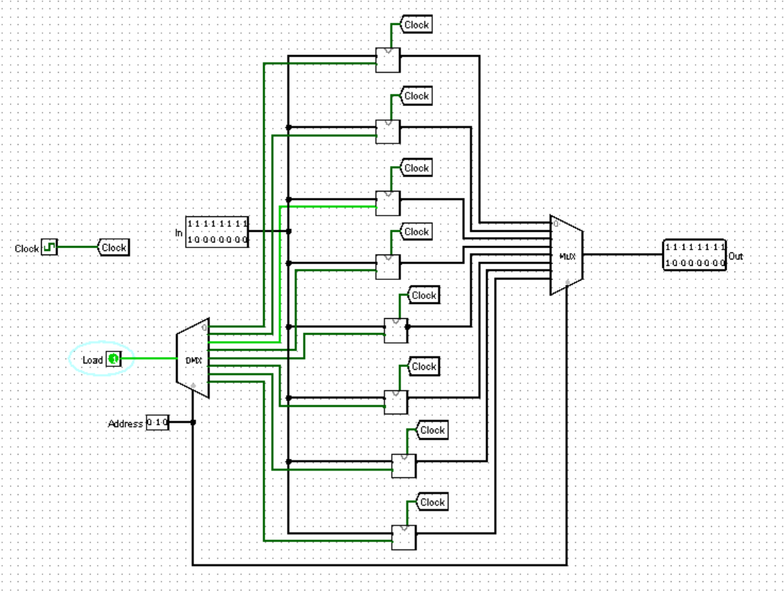

- RAM64
CHIP RAM64 {
IN in[16], load, address[6];
OUT out[16];

PARTS:
DMux8Way(in=load, sel=address[3..5], a=l0, b=l1, c=l2, d=l3, e=l4, f=l5, g=l6, h=l7);

RAM8(in=in, load=l0, address=address[0..2], out=out0);
RAM8(in=in, load=l1, address=address[0..2], out=out1);
RAM8(in=in, load=l2, address=address[0..2], out=out2);
RAM8(in=in, load=l3, address=address[0..2], out=out3);
RAM8(in=in, load=l4, address=address[0..2], out=out4);
RAM8(in=in, load=l5, address=address[0..2], out=out5);
RAM8(in=in, load=l6, address=address[0..2], out=out6);
RAM8(in=in, load=l7, address=address[0..2], out=out7);

Mux8Way16(a=out0, b=out1, c=out2, d=out3, e=out4, f=out5, g=out6, h=out7, sel=address[3..5], out=out);

}
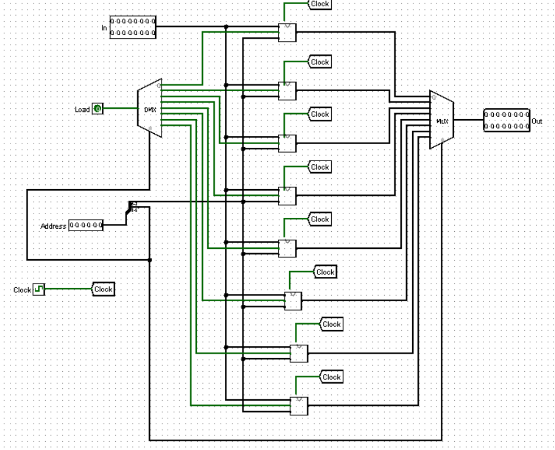
25.RAM512
CHIP RAM512 {
IN in[16], load, address[9];
OUT out[16];
PARTS:
DMux8Way(in=load, sel=address[6..8], a=l1, b=l2, c=l3, d=l4, e=l5, f=l6, g=l7, h=l8);

RAM64(in=in, load=l1, address=address[0..5], out=r1);
RAM64(in=in, load=l2, address=address[0..5], out=r2);
RAM64(in=in, load=l3, address=address[0..5], out=r3);
RAM64(in=in, load=l4, address=address[0..5], out=r4);
RAM64(in=in, load=l5, address=address[0..5], out=r5);
RAM64(in=in, load=l6, address=address[0..5], out=r6);
RAM64(in=in, load=l7, address=address[0..5], out=r7);
RAM64(in=in, load=l8, address=address[0..5], out=r8);
Mux8Way16(a=r1, b=r2, c=r3, d=r4, e=r5, f=r6, g=r7, h=r8, sel=address[6..8], out=out);
}

